**Abstract**

Managing daily expenses efficiently is a crucial aspect of financial stability for both **salaried and non-salaried individuals**. The  **Personal Expense Tracker (PET)** is a computerized **expense management system** designed to simplify the process of tracking and managing daily expenditures. This system eliminates the need for traditional paper-based record-keeping by offering a digital platform where users can store, retrieve, and analyze their financial data conveniently.

PET is developed using **Python** and is specifically designed for **Android devices**, ensuring accessibility and ease of use. The application features an intuitive user interface that enables users to log expenses effortlessly, categorize spending, and generate reports for better financial planning. By leveraging structured **datasets**, PET ensures systematic data storage, quick retrieval, and efficient record management.

The primary objective of PET is to provide a **user-friendly, efficient, and accurate** financial tracking tool that helps individuals **gain better control over their finances**. With automation, error reduction, and real-time data access, PET serves as a practical solution for personal finance management. Future enhancements may include additional features such as **budget planning, data visualization, and multi-device synchronization** to further improve usability and effectiveness.

**Title: Expense Tracker**

**Mini Project Report submitted in partial fulfilment of the requirement for the award of the degree of**

**BACHELOR OF TECHNOLOGY**

***in***

**COMPUTER SCIENCE AND ENGINEERING**

***By***

Jeevana P -122210701117

Maddireddy Sravani -122210601131

Putta Keerthana -122210701142

**Under the Guidance of**

**Sambangi Jayashankar**

**Bytexl trainer**





**SCHOOLOFTECHNOLOGY**

**THE APOLLO UNIVERSITY**

**Murukampattu,Chittoor–517127,AndhraPradesh 2024**

Table of Contents

1. Introduction

2. Objectives

3. Features & Functionalities

4. System Architecture & Design

5. Implementation

6. Advantages & Disadvantages

7. Results

8. Reference

9. Conclusion

**1. Introduction :**

Managing personal finances effectively is a crucial aspect of achieving financial stability, yet many individuals struggle with maintaining accurate financial records. Traditional methods of tracking income and expenses, such as manual record-keeping or paper-based documentation, can be cumbersome, time-consuming, and prone to human errors. Misplaced receipts, incorrect calculations, and difficulty in organizing past transactions can lead to financial mismanagement. The **Expense Tracker** is designed to address these challenges by providing a **streamlined, digital solution** for managing finances with ease and accuracy. Whether a person is salaried, self-employed, or managing irregular income, this application enables them to maintain a well-organized financial history. By **automating expense tracking**, users can eliminate the hassle of manual calculations, reducing errors and ensuring they have a **clear, real-time overview** of their financial situation at any given moment.

The Expense Tracker offers a **user-friendly interface** that allows individuals to effortlessly input, categorize, and analyze their financial transactions. With **a well-structured digital platform**, users can track their income, expenses, and spending patterns without struggling with traditional bookkeeping methods. The application categorizes expenditures based on predefined and custom categories, making it easy to understand where money is being spent. Additionally, it provides **detailed insights and reports**, which help users analyze their financial habits and make well-informed decisions. With features like **budgeting tools, transaction history, and graphical expense visualization**, users can better plan their finances, reduce unnecessary expenses, and work toward financial goals. Whether for personal budgeting or business expense tracking, the app ensures that financial data is systematically stored and easily accessible whenever needed.

Designed specifically for **Android devices**, the Expense Tracker integrates a **secure and reliable backend powered by Python**, ensuring efficient data management and privacy protection. Unlike traditional methods, where data can be lost or tampered with, the Expense Tracker securely stores all financial records, providing users with a **safe and organized financial tracking system**. The application also features **automated tracking**, allowing users to set **recurring transactions**, such as monthly rent, subscriptions, or utility bills, ensuring they never miss a payment. Additionally, **real-time data visualization tools**, such as graphs and charts, offer users an easy way to track their financial progress. By incorporating advanced features like **multi-language support and theme customization**, the app enhances accessibility for diverse users. With its combination of efficiency, accuracy, and ease of use, the Expense Tracker empowers individuals to develop better financial habits, improve budgeting strategies, and achieve greater financial discipline.

**2. Objectives:**

A user-friendly interface is crucial for any financial management application, ensuring that users can effortlessly navigate and manage their expenses.

1. The design should be intuitive, with clearly labeled icons, an easy-to-read dashboard, and seamless transitions between sections.
2. To add customization options, including themes and font adjustments, can further improve usability, ensuring a pleasant and accessible interface for users of all backgrounds.
3. By integrating a responsive design ensures accessibility across various devices, allowing users to manage their finances from desktops, tablets, and smartphones.
4. Categorizing and analyzing spending patterns is essential for users to make informed financial decisions. By grouping expenses into categories such as food, transportation, utilities, and entertainment, users can gain insights into their spending habits and identify areas for improvement.
5. Incorporating filters and search functions to allow users to track specific transactions or compare monthly expenses.
6. Encouraging financial awareness, as this feature helps users develop better money management strategies, reducing unnecessary spending and promoting savings.

**3. Features & Functionalities**

**Add Expense:**

The ability to add expenses is a fundamental feature of the Expense Tracker, allowing users to maintain a detailed record of their financial transactions. Users can enter essential details such as the date, category, and amount, ensuring an organized and structured expense log. By categorizing expenses, users can gain insights into their spending habits, making it easier to analyze financial patterns. The category selection is provided through a predefined list, ensuring consistency in record-keeping and preventing misclassifications. This feature eliminates the risk of missing transactions, ensuring that all expenditures are accounted for in real time.

Additionally, the application ensures ease of use by offering a simple and interactive input form. The structured format minimizes errors while entering data, ensuring accuracy in financial tracking. With a user-friendly interface, users can quickly log transactions without unnecessary complexity. The system also supports quick edits to recently added expenses, allowing users to correct mistakes without hassle. By maintaining a digital record of expenses, users can avoid the inconvenience of manual calculations and paperwork, making financial management more efficient and convenient.

**View Expense:**

The View Expense feature provides users with an organized and efficient way to review their past transactions. Instead of scrolling through an extensive list, users can search for specific expenses using the category filter. This functionality enables users to focus on particular spending areas, making financial analysis more streamlined. Whether tracking grocery expenses or analyzing entertainment costs, users can retrieve relevant data instantly. The search function also supports sorting by date, allowing users to track monthly or weekly expenditures effortlessly.

Beyond search capabilities, the application ensures that all displayed expenses are structured in an easy-to-read format. Transactions are listed in a clear tabular view, ensuring users can quickly scan through past expenses. The system provides additional details such as timestamps and payment methods (if applicable), further enhancing transaction visibility. This structured approach makes reviewing expenses seamless, helping users make more informed financial decisions based on historical spending trends.

**Total by Category:**

One of the most insightful features of the Expense Tracker is its ability to calculate total expenditures by category. Instead of manually summing up expenses, the system automatically aggregates data, providing users with an instant breakdown of their financial habits. This feature helps users identify which categories consume the largest portion of their budget, making it easier to adjust spending behaviors. Whether users are overspending on dining out or entertainment, this tool helps pinpoint areas where financial adjustments are needed.

Additionally, the application presents this data in a user-friendly format, making it easier to interpret. The system can display totals as numerical values or graphical representations such as pie charts, enhancing financial awareness. By visualizing expense distribution, users can gain a deeper understanding of their spending patterns. This feature plays a crucial role in budget management, allowing individuals to allocate resources wisely and work towards financial stability.

**Edit Expense:**

To maintain accuracy in financial tracking, the Expense Tracker allows users to modify existing transactions. This feature ensures that users can correct mistakes or update expense details such as date, category, or amount. In financial management, errors in recording transactions can lead to miscalculations, making this functionality crucial. Users can simply navigate to a previously recorded transaction and make the necessary adjustments, ensuring that their records remain accurate and up to date.

In addition to editing transactions, users can also delete unnecessary or incorrect entries. This helps keep financial records clean and prevents duplicate expenses from skewing the budget analysis. A confirmation prompt ensures that users do not accidentally remove critical transactions, adding a layer of security to the deletion process. By giving users full control over their financial data, the application ensures that the records remain reliable and organized.

**Settings :**

The settings menu allows users to personalize the application according to their preferences. One of the key features in this section is language customization, supporting multiple languages such as English and Telugu. This multilingual capability ensures accessibility for a diverse range of users. Another functionality of this feature is that there is size of text option that can be changed by user according to their preference. This feature helps users to change size according to their liking. Hence this feature helps in better understanding of the expense tracker.

**Help:**

This function guides new users on how to navigate the application effectively. This section provides step-by-step instructions and troubleshooting support, ensuring users can maximize the application’s features. The inclusion of an exit button ensures users can safely close the application without disrupting their financial records. With these customization options, the Expense Tracker caters to a wide range of user preferences, making financial management more accessible and convenient.

**Exit:**

This button in an expense tracker ensures a smooth and secure way for users to close the application without losing any data. When a user clicks on the exit button, the system should automatically save the latest transactions, settings, and preferences before closing. A confirmation prompt can help prevent accidental exits. Additionally, implementing an auto-save feature ensures that all expenses are stored safely in local or cloud storage, reducing the risk of data loss. If the application supports multiple sessions, users should be able to resume exactly where they left off upon reopening. An optimized exit process enhances user experience by providing a secure and hassle-free closure mechanism while maintaining data integrity.

**4. System Architecture & Design**

The Expense Tracker is built using Python and a Graphical User Interface (GUI) approach, ensuring ease of use and accessibility for users.

**System Components**

1. **Frontend (GUI):**
   * Developed using Python's GUI frameworks such as Tkinter .
   * Provides an intuitive and user-friendly interface.
   * Allows users to input, view, and manage financial transactions.
   * Implements a structured menu and navigation system for easy usability.
   * Offers visual elements like buttons, tables, and input fields for enhanced interaction.
2. **Backend (Data Processing):**
   * Handles data storage, retrieval, and processing.
   * Implements logic for transaction categorization and reporting.
   * Ensures fast and efficient execution of financial calculations.
   * Uses modular functions and classes to maintain a scalable codebase.
3. **Database Management:**
   * We used Excel for storage of expenses.
   * Stores transaction details and user preferences.
   * Ensures data integrity and easy retrieval for reporting purposes.
   * Supports indexing and optimized queries for faster data access.
   * Implements data validation techniques to avoid inconsistencies.
4. **Additional features:**
   * Added a calender widget for making GUI more interactive and easy.
   * Allows users to change language and size of text which enables them to read conveniently.
   * Allows adding details like amount, date, category, and payment method.
   * Implemented zoom functionality for better visibility.
   * Used language settings and icon-based navigation.
   * Added icons and labels for better user navigation

**5. Implementation**

Designing a comprehensive Expense Tracker application involves integrating various features to enhance user experience and functionality. Below is an elaboration on the specified requirements, along with additional considerations to ensure a robust application.

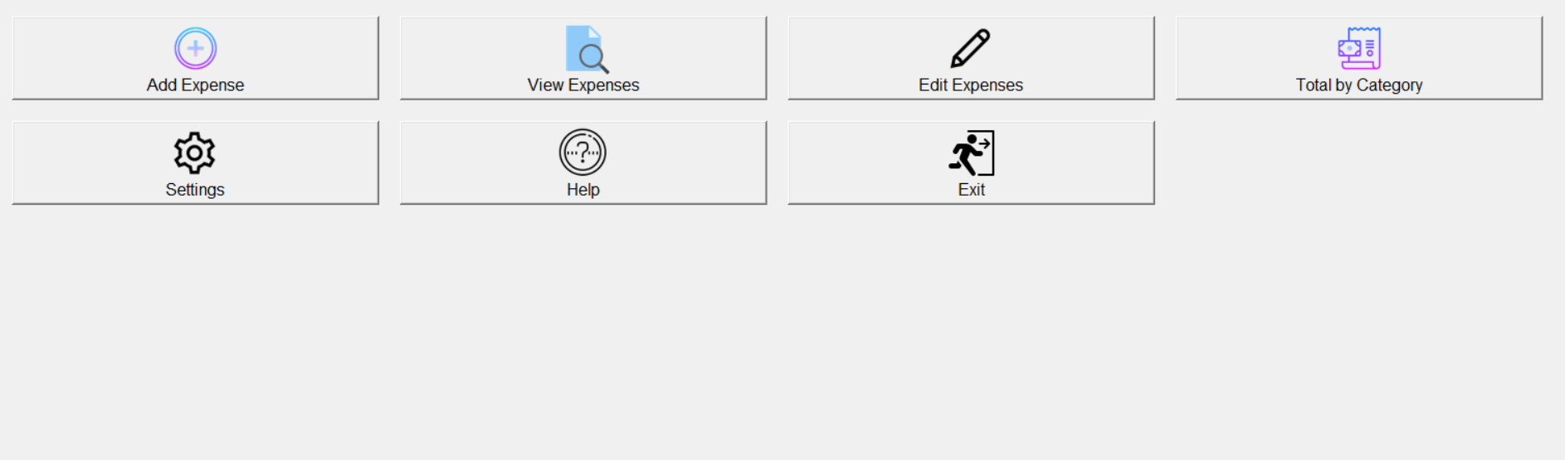

**1. Add Expense:**

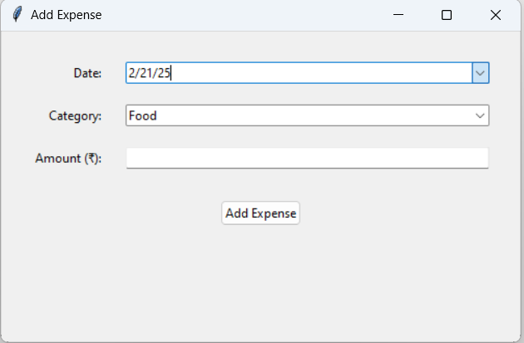Users should be able to **record expenses** by entering details like the **date, category, and amount**, ensuring accurate financial tracking. This helps organize spending habits and provides insights into budgeting and expense management.

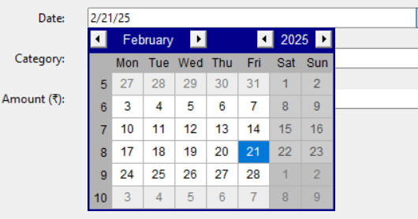- Date: Allow users to select the date of the expense, defaulting to the current date. Has calender widget to enhance user usability.

- Category: Provide a dropdown list of predefined categories (e.g., Food, Transportation, Utilities) for users to select from.

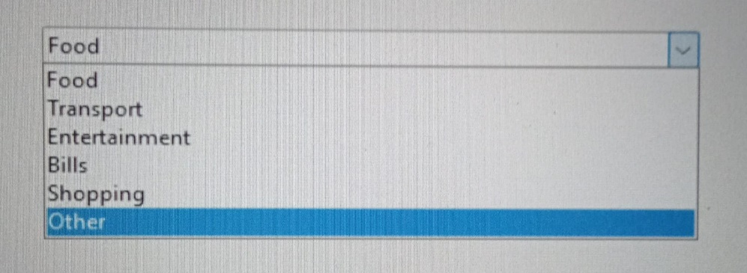

- Amount: Input field for the expense amount, ensuring validation for numerical input.

**2. View Expense:**

- Search by Category: Enable users to filter and view expenses based on selected categories, displaying results in a clear, organized manner.

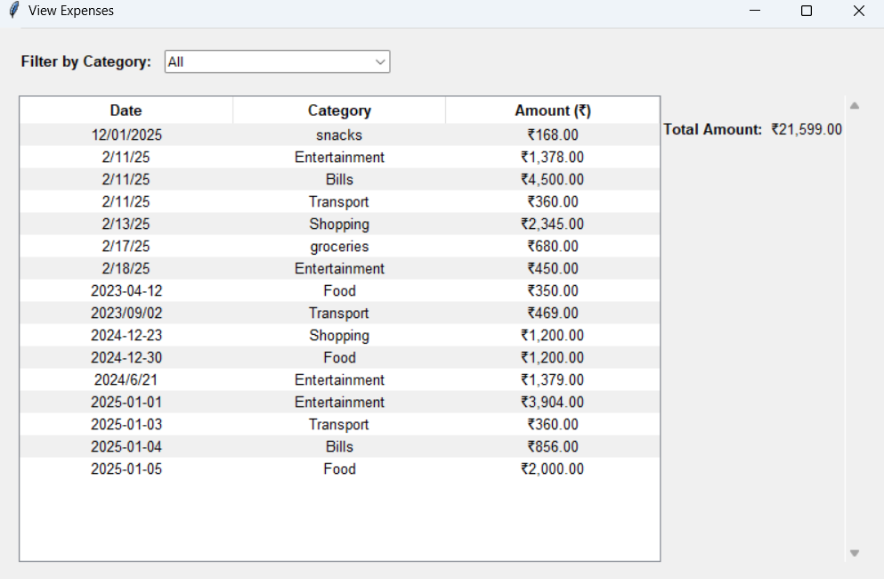

**3. Total by Category:**

- Aggregation: Calculate and display the total amount spent in each category over a specified period, aiding users in understanding their spending patterns.

This displays a **"Total Expenses by Category"** summary in a table format. It includes expense categories such as **Bills, Entertainment, Food, Shopping, Transport, Groceries, and Snacks**, with corresponding **total amounts and percentage of total expenses**. The **Grand Total is ₹21,599.00**, and the data is neatly structured for easy financial analysis.

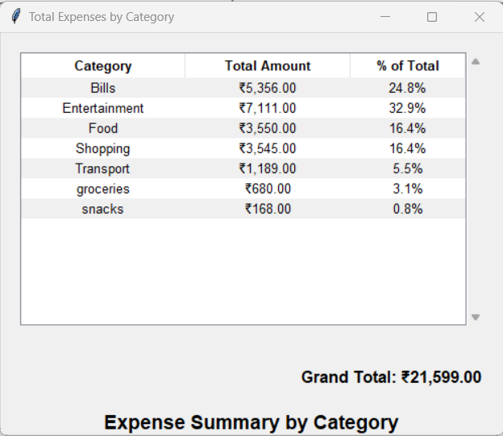

**4. Editing Expenses:**

- Filtering: Allows to filter based on categories the user wants.

- Deletion: Allow users to remove expenses, with confirmation prompts to prevent accidental deletions.

The image displays an **"Edit Expenses"** interface of an expense tracker. It contains a table listing expenses with **Date, Category, and Amount** columns. A **filter dropdown** allows users to filter expenses by category. On the right, there is a **"Delete Expense"** button for removing selected entries. Various expense categories like **Food, Transport, Entertainment, Shopping, Bills, and Snacks** are listed with different dates and amounts, ensuring detailed expense management.

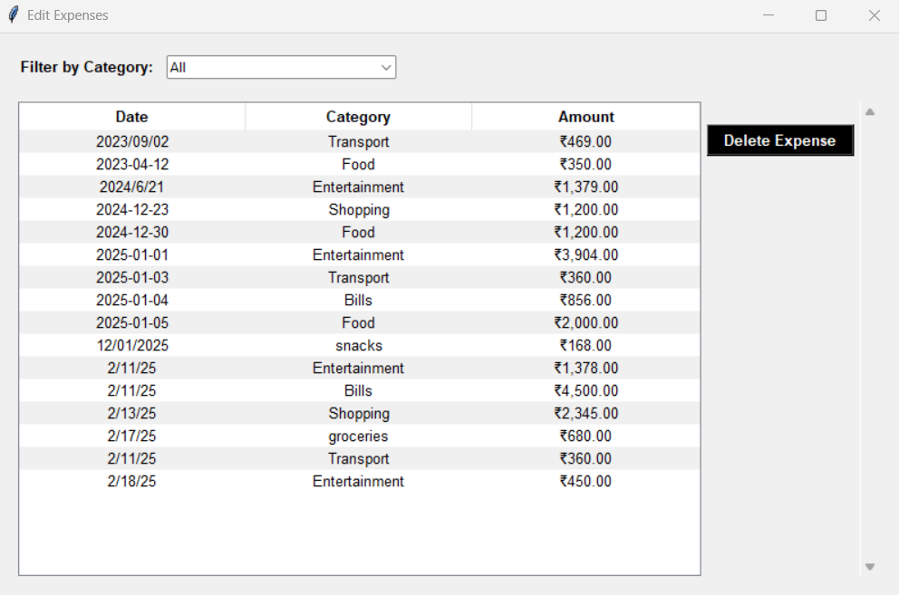

**5. Settings Function:**

- Language Selection: Offer multiple language options—English, Telugu—to cater to a diverse user base.

- Zoom Text: allows to zoom text for better readability.

The image shows the **"Settings"** interface of an expense tracker application. It includes options to **change the language** using a dropdown menu, with "English" currently selected. Additionally, there is a **zoom text** feature, allowing users to adjust text size, with "12" as the default. Below these options, an **"Apply Changes"** button enables users to save their preferences. The interface is minimalistic and user-friendly, ensuring accessibility and customization for different user needs.

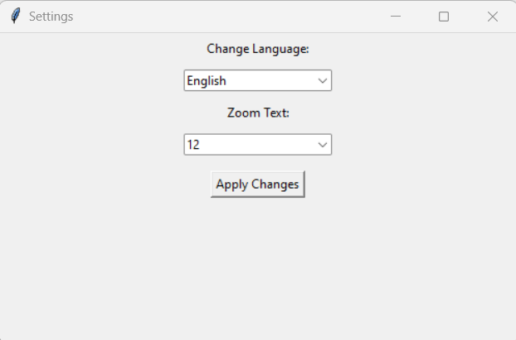

**7. Help Function:**

- User Guidance: Include a help section that offers clear instructions on how to use the application, possibly with FAQs and troubleshooting tips.

The image displays the **"Help"** section of an **Expense Tracker - User Guide**. It provides an overview of what an expense tracker is, describing it as a personal finance tool that helps users **monitor and manage spending habits** for better financial decisions. The guide outlines reasons to use an expense tracker, including **financial awareness, budget management, financial goals, expense reduction, financial planning, and tax preparation**. Additionally, it highlights key features like **adding expenses with date, amount, category, and description** and **category management**. A **"Close"** button is present at the bottom, allowing users to exit the help window.

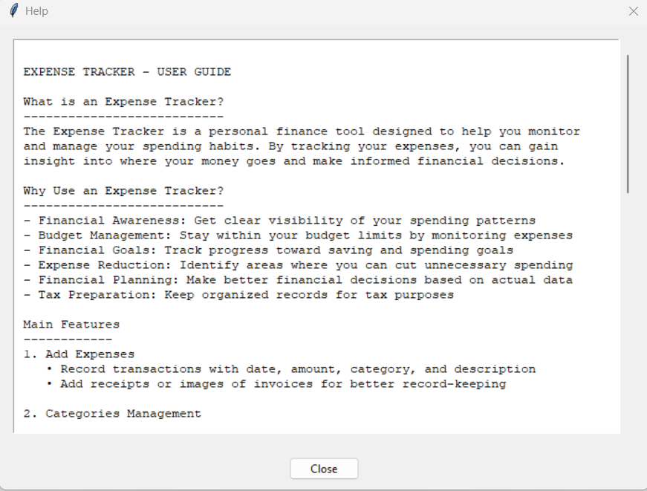

**8. Exit Button:**

- Application Closure: Provide a clear and accessible exit button to allow users to close the application safely.

**User Interface Considerations**

**1. Window Centering:**

- Initial Positioning: Ensure the main application window opens centered on the user's screen for a consistent and professional appearance.

**2. Parent-Child Window Behavior :**

- Focus Management: When a child window (e.g., settings or help) opens, blur or disable the parent window to prevent interaction until the child window is closed, enhancing focus and preventing errors.

**3. Zoom Functionality:**

- Accessibility: Implement zoom features to allow users to adjust the interface size for better readability and accessibility.

**4. Localization:**

- Language Support: Implement a system to handle multiple languages, ensuring all text elements are translated appropriately based on user selection.

**5. Icons and Labels:**

- Intuitive Navigation: Use clear, representative icons for all major functions, with labels positioned below them to aid in user understanding and navigation.

Additional Considerations

- Data Persistence: Implement a reliable method for storing user data, such as a local database or secure cloud storage, ensuring data is saved between sessions.

- Security: Incorporate features like password protection or user authentication to secure sensitive financial data.

- Responsive Design: Ensure the application is responsive to different screen sizes and resolutions, providing a consistent experience across various devices.

- Error Handling: Implement comprehensive error handling to provide user-friendly messages and prevent application crashes.

- Regular Updates: Plan for regular updates to address bugs, introduce new features, and improve performance based on user feedback.

By integrating these features and considerations, the Expense Tracker application will offer a robust, user-friendly experience that caters to a wide audience, ensuring effective personal finance management.

**6. Advantages & Disadvantages**

**Advantages**

* **Efficient Financial Management:** Users can easily track income and expenses in one place.
* **Automation & Accuracy:** Eliminates human errors associated with manual tracking.
* **Security:** Local storage ensures user data is not exposed online.
* **User-Friendly Interface:** The GUI-based design makes it accessible to all users.
* **Budget Planning:** Helps users set and track financial goals effectively.
* **Offline Accessibility:** Allows expense tracking without requiring an internet connection.

**Disadvantages**

* **Limited Accessibility:** Data is stored locally, making it device-dependent.
* **No Cloud Syncing:** Users cannot access their data from multiple devices.
* **Manual Backup Required:** Users need to ensure regular data backups.
* **Limited Platform Support:** Currently supports only Python-based environments.
* **Initial Learning Curve:** Users unfamiliar with GUI-based applications may take time to adapt.
* **No AI-driven Insights:** Lacks predictive analytics for advanced financial insights.

**7. Results**

The Expense Tracker has successfully provided users with an efficient and structured way to manage their finances. Users can now log their income and expenses, generate reports, and analyze their spending patterns without relying on traditional paper-based tracking.

**Key results achieved include:**

**1.Improved Financial Awareness**

The Expense Tracker has significantly enhanced users’ understanding of their financial habits by providing real-time insights into their income and expenditures. By categorizing expenses, users can easily identify where their money is going and adjust their spending accordingly. This level of awareness allows individuals to make informed financial decisions, helping them prioritize essential expenses over discretionary spending. Through regular monitoring, users develop better financial discipline, reducing unnecessary expenditures.

Moreover, the application's ability to track historical spending patterns enables users to recognize trends and make proactive adjustments. By reviewing past transactions, users can analyze which categories consume the largest portion of their budget. This self-awareness encourages responsible financial behavior, leading to long-term savings and better resource allocation. The ability to compare spending across different time periods also helps users assess financial growth and progress toward financial stability.

**2.Time Savings**

One of the major advantages of the Expense Tracker is the automation of financial tracking, which significantly reduces the time and effort required for manual record-keeping. Previously, users had to record transactions manually in notebooks or spreadsheets, which was both tedious and prone to errors. By automating this process, the application eliminates the need for repetitive data entry, allowing users to focus on analyzing their finances rather than spending time on bookkeeping.

Furthermore, the application's structured interface ensures that transactions can be logged quickly and efficiently. Users can input expenses in just a few taps, select categories from a predefined list, and generate reports instantly. The time saved from manual calculations and organizing receipts allows users to concentrate on financial planning rather than administrative tasks. This efficiency makes financial management more convenient and accessible, ensuring that users stay on top of their expenses without investing excessive time.

**3.Data Visualization**

Understanding financial data can be challenging when presented in raw numerical formats. The Expense Tracker overcomes this issue by incorporating graphical reports that visually represent users’ spending patterns. By providing pie charts, bar graphs, and trend lines, the application helps users comprehend their financial situation at a glance. These visualizations make it easier to identify trends, such as increasing expenses in certain categories or fluctuations in monthly spending.

Additionally, visual data presentation enhances decision-making by allowing users to quickly compare financial performance across different time periods. For instance, users can analyze how their spending in one month compares to the previous month and make necessary adjustments. This level of clarity empowers users to take corrective actions, optimize their budgets, and improve overall financial management. By converting complex financial data into easy-to-understand visual insights, the application enhances user engagement and financial literacy.

**4.Reliability**

The Expense Tracker is designed to maintain accuracy and efficiency in recording financial transactions, ensuring that users can depend on it for managing their finances. Unlike traditional manual tracking methods that are prone to errors, the application provides a structured and automated approach that eliminates discrepancies. The accuracy of stored financial data ensures that users always have a reliable reference when making financial decisions.

Additionally, the system is built with a robust architecture that minimizes the risk of data loss or corruption. Users can trust the application to keep their records intact, allowing them to track financial progress over time. The structured approach to expense tracking and categorization ensures that financial records remain well-organized and easily accessible. By providing a secure and dependable platform, the Expense Tracker enhances user confidence in financial management, enabling them to make well-informed decisions based on precise data.

**8.Reference**

1**. Personal Finance Management Principles**  
 Kapoor, J. R., Dlabay, L. R., & Hughes, R. J. (2018). *Personal Finance*. McGraw-Hill

Education.

• https://www.mheducation.com/highered/product/Personal-Finance-Kapoor.html

• <https://www.amazon.com/Personal-Finance-Jack-Kapoor/dp/1260013995>

2. **Expense Tracking and Budgeting Techniques**  
 Gitman, L. J., & Joehnk, M. D. (2019). *Personal Financial Planning*. Cengage Learning.  
 <https://www.cengage.com/c/personal-financial-planning-14e-gitman/9781337099752>

3**. Financial Software Development Using Python**  
 Lutz, M. (2013). *Learning Python*. O'Reilly Media.  
 <https://www.oreilly.com/library/view/learning-python-5th/9781449355722>

4. **Graphical User Interface (GUI) Design for Financial Applications** Grayson, J. (2017). *Python and Tkinter Programming*. Manning Publications.  
 https://www.manning.com/books/python-and-tkinter-programming

<https://www.amazon.com/Python-Tkinter-Programming-John-Grayson/dp/1884777813>

5. **Data Visualization in Financial Applications**

* McKinney, W. (2017). *Python for Data Analysis: Data Wrangling with Pandas, NumPy, and Jupyter*. O'Reilly Media.
  + <https://wesmckinney.com/book>

**6.Importance of Budgeting in Financial Planning**

* Murdoch, J. (2020). *The Financial Diet: A Total Beginner’s Guide to Getting Good with Money*. HarperCollins.
  + <https://www.amazon.com/Financial-Diet-Total-Beginners-Getting/dp/1250176166>

7. **User Experience (UX) and Interface Design for Financial Applications**

* Norman, D. A. (2013). *The Design of Everyday Things: Revised and Expanded Edition*. Basic Books.
  + <https://www.basicbooks.com/titles/don-norman/the-design-of-everyday-things/9780465072996>

8 .**Mobile App Development Best Practices**

* Hashimi, S., Komatineni, S., & MacLean, D. (2010). *Pro Android 4*. Apress.
  + <https://link.springer.com/book/10.1007/978-1-4302-3930-0>

9. **Role of Digital Solutions in Financial Management**

* CFA Institute. (2021). *Fintech and Digital Innovation: Implications for Financial Planning and Wealth Management*.
  + https://www.cfainstitute.org/en/research/industry-research/fintech-and-digital-innovation

10. **Security Measures in Expense Tracking Applications**

* Anderson, R. (2020). *Security Engineering: A Guide to Building Dependable Distributed Systems*. Wiley.
  + <https://www.wiley.com/en-us/Security+Engineering%3A+A+Guide+to+Building+Dependable+Distributed+Systems%2C+3rd+Edition-p-9781119642787>

**9.Conclusion**

The Personal Expense Tracker (PET) has been developed as a reliable and user-friendly financial management tool aimed at simplifying expense tracking for both salaried and non-salaried individuals. By leveraging a computerized system rather than traditional paper-based record-keeping, PET provides a structured and efficient approach to managing daily financial transactions. The system ensures users can easily store, retrieve, and analyze their financial data with minimal effort. Through its Python-based backend and Android compatibility, PET enhances accessibility while maintaining accuracy in financial tracking.

The PET application successfully integrates features such as expense logging, categorization, and financial data retrieval, allowing users to gain better insights into their spending patterns. The implementation of a structured dataset ensures systematic data storage and quick retrieval, improving overall record management efficiency. Moving forward, additional enhancements such as cloud integration, AI-driven financial insights, and multi-device synchronization could further improve PET’s capabilities. Ultimately, PET stands as a practical and efficient solution for users seeking a more organized and automated approach to managing their daily expenses.

With its intuitive interface and structured data management, PET ensures that users can efficiently monitor their financial transactions without unnecessary complexity. The system’s automation and categorization features reduce manual effort, making financial tracking more accessible and accurate. Additionally, its Android compatibility and Python-based framework offer a scalable foundation for future enhancements. Implementing user feedback-driven improvements will further refine PET’s functionality and usability. As financial management becomes increasingly digital, PET serves as a valuable tool for individuals seeking financial stability and organization.